**GIBBONS V. OGDEN (1824)**

**KEY TERMS**

* **Interstate**: Between two states.
* **Regulate**: To control or supervise by means of rules and regulations.
* **Trade**: The transfer of goods or services from one person or group to another, often in exchange for money.

On one side of the river was New York: on the other, New Jersey. Aaron Ogden stood on the New York side and smiled. Ogden had a license from New York to operate on the state’s waterways. Since New York required all out-of-state operators to get expensive permits (protecting Ogden from competition), Ogden figured he would be doing good business. But Thomas Gibbons, Ogden’s former business partner, was also a steamboat operator. And Gibbons had a license from the federal government to operate a steamboat through interstate waterways. Ogden and Gibbons each thought his own license should outweigh the other man’s. The case went to the Supreme Court.

The Court had to decide—who had the power to regulate navigation on interstate waterways: Congress, or the individual states?

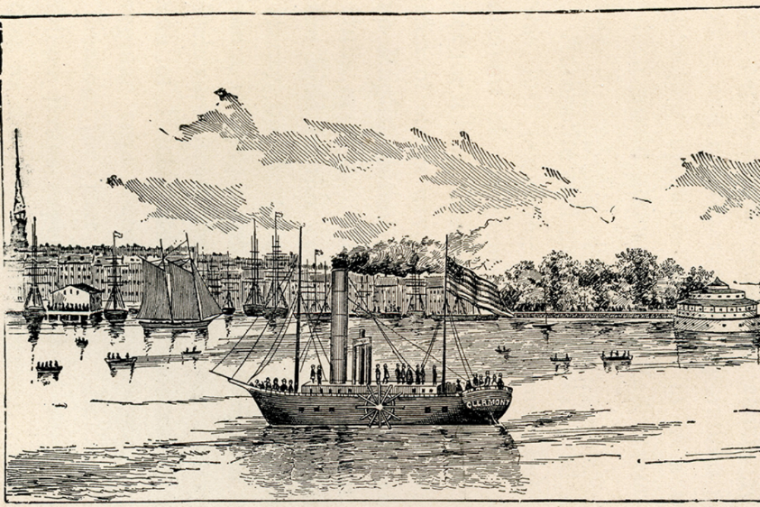

**QUESTION**: What do **you** think the Court decided, and why?

|  |
| --- |
|  |

**GIBBONS V. OGDEN (1824)**

The following is a list of arguments in the *Gibbons v. Ogden*court case. Read through each argument and decide whether it supports Gibbons' side in favor of Congress's regulation of commerce (G), Ogden's side in favor of New York's regulation of commerce (O), both sides (BOTH), or neither side (N).

|  |  |
| --- | --- |
| **ARGUMENT** | **WHO DOES IT SUPPORT?** |
| 1) Article I, Section 8 of the U.S. Constitution states:  *"The Congress shall have the Power . . . To regulate Commerce with foreign Nations, and among the several States, and with the Indian Tribes. . . ."* | Gibbons |
| 2) The license issued to Gibbons by Congress gave him permission to be "employed in carrying on the coasting trade." The boats operated by Gibbons were used to transport passengers, not goods, so Congress should not be able to regulate that movement. |  |
| 3) The 10th Amendment to the U.S. Constitution states: "The powers not delegated to the United States by the Constitution, nor prohibited by it to the States, are reserved to the States respectively, or to the people." |  |
| 4) There are many areas in which the national government and state governments have concurrent power (shared power). For instance, both levels of government can levy taxes. |  |
| 5) In the case of *McCulloch v. Maryland* (1819), the Supreme Court of the United States ruled that when state and federal laws conflict, the federal law is supreme. |  |
| 6) Under the U.S. Constitution, states are able to pass inspection laws, quarantine laws, health laws of every description, as well as laws for regulating the internal commerce of a state. |  |
| 7) Under the Articles of Confederation, states were free to pass laws regarding interstate as well as intrastate commerce. This resulted in some laws that inhibited the free flow of commerce in the United States as a whole. For instance, some states levied import taxes and tariffs on goods coming from other states. |  |

**THE DECISION:**

Among the powers granted to Congress in Article I, Section 8 of the U.S. Constitution is the power to regulate interstate commerce. Over time, legislators, lawyers, politicians, and business people have argued over just what the commerce power means. For instance, it may be clear that the commerce power would give Congress the ability to make laws regarding transportation networks, such as train lines and highways, that cross state lines. However, would the commerce power give Congress the ability to establish regulations on the production of goods and services that will eventually cross state lines? These and other questions regarding the commerce power have been answered by numerous cases heard by the Supreme Court of the United States. However, the question of what the Commerce Clause entitles Congress to do and legislate on is still a very open question.

In the case of Gibbons v. Ogden, the Court ruled in Gibbons’ favor, holding that the Constitution gave this power to Congress. The opinion, written by Chief Justice John Marshall, focused on the meaning of the Commerce Clause in Article I, Section 8 of the Constitution, which states that Congress has the power “[t]o regulate Commerce with foreign Nations, and among the several States…” The word “among,” the Court ruled, “may very properly be restricted to that commerce which concerns more States than one.”

The Court acknowledged that the Constitution did not expressly grant Congress the power to regulate navigation on interstate waterways. But Marshall pointed out that all the states were connected by waterways and commerce would be impossible without navigating them. Therefore, the power to regulate transporting goods on waterways was “[necessary and proper](https://billofrightsinstitute.org/founding-documents/constitution/)” for Congress to carry out its enumerated power to “regulate commerce…among the several states.”

If individual states had their own rules about commerce with other states, trade would be next to impossible. In fact, one important purpose of replacing the Articles of Confederation had been to “rescue [the United States] from the embarrassing and destructive consequences, resulting from the legislation of so many different States, and to place it under the protection of a uniform law.” States could not set their own rules for commerce in ways would interfere with the national government’s ability to carry out its power to establish uniform rules.

Finally, the decision affirmed that state laws that contradict constitutional acts of Congress “must yield” to the supremacy of the Constitution, as stated in Article VI: “This Constitution and the laws of the United States which shall be made in pursuance thereof … shall be the supreme law of the land.”

**QUESTIONS**: Answer each question below about the reading in a complete sentence.

1. What was the constitutional question in *Gibbons v. Ogden* (1824)?

|  |
| --- |
|  |

1. How did the Court rule?

|  |
| --- |
|  |

1. List some ways this ruling affected your life. For example, do you ever buy things that were made in other states? If you had a successful invention and wanted to sell it around the country, would you face different sets of trade requirements in each state?

|  |
| --- |
|  |

1. The Court held that “the word used in the Constitution [“commerce”]… has been always understood to comprehend navigation within its meaning, and a power to regulate navigation is as expressly granted as if that term had been added to the word “commerce”?  Do you agree with the Court on the meaning of this particular word? Why or why not?  What are the advantages of interpreting the Constitution this way? What are the dangers?

|  |
| --- |
|  |

1. The Supremacy Clause (Article VI) of the Constitution states, “*This Constitution, and the laws of the United States which shall be made in pursuance thereof…shall be the supreme law of the land; and the judges in every state shall be bound thereby, anything in the Constitution or laws of any State to the contrary notwithstanding*.” Does this clause mean that a state law that contradicts **any** act of Congress is void? How do you know?

|  |
| --- |
|  |

1. Some people believe that the decision in *Gibbons v. Ogden* did more to pull the American people into a nation than any other event in the country's history except war. Explain this assertion.

|  |
| --- |
|  |